# Visualization-

# Raw Audio Waveform(Sound Waves)-

Helps in understanding the overall structure of audio (amplitude vs. time). Gives insight into the dynamics of a song (e.g., quiet vs. loud segments, transitions).

How to Use: Plot the waveform for audio files from different genres to observe: Differences in energy levels. Time-domain patterns (e.g., reggae might have softer dynamics compared to rock).

Key Observations: Identify genres with sharp attacks (e.g., drums in rock). Smooth waveforms may indicate calmer genres (e.g., classical, jazz).

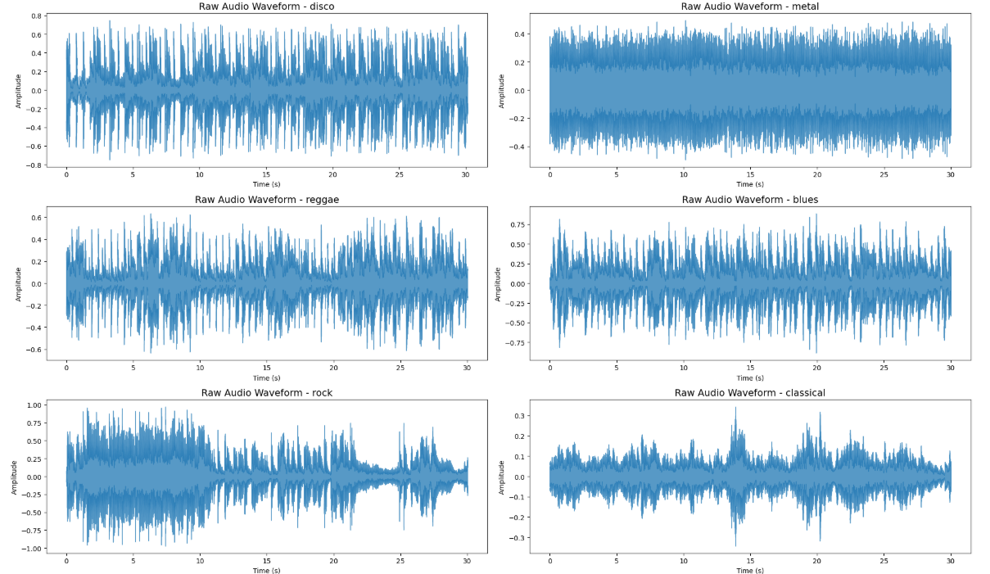

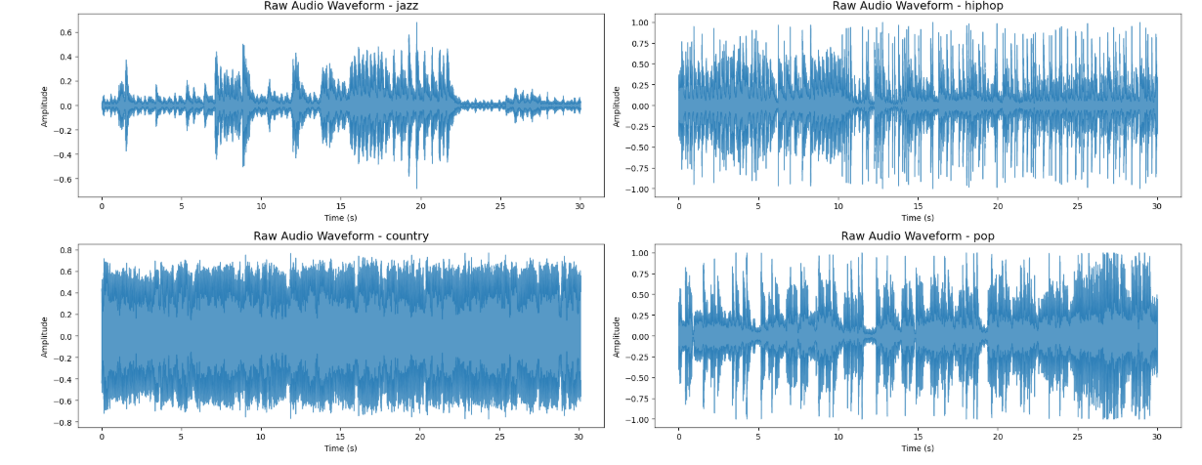

# Spectrogram

Displays the frequency content of audio over time. Offers a visual signature of different genres (e.g., high frequencies dominate electronic music, while lower frequencies dominate blues).

How to Use: Generate a log-mel spectrogram or short-time Fourier transform (STFT) spectrogram. Compare spectrograms for different genres to highlight frequency distribution patterns.

Key Observations: Genres like classical may have broad frequency coverage. Rock or metal may show dense high-energy bands across time.

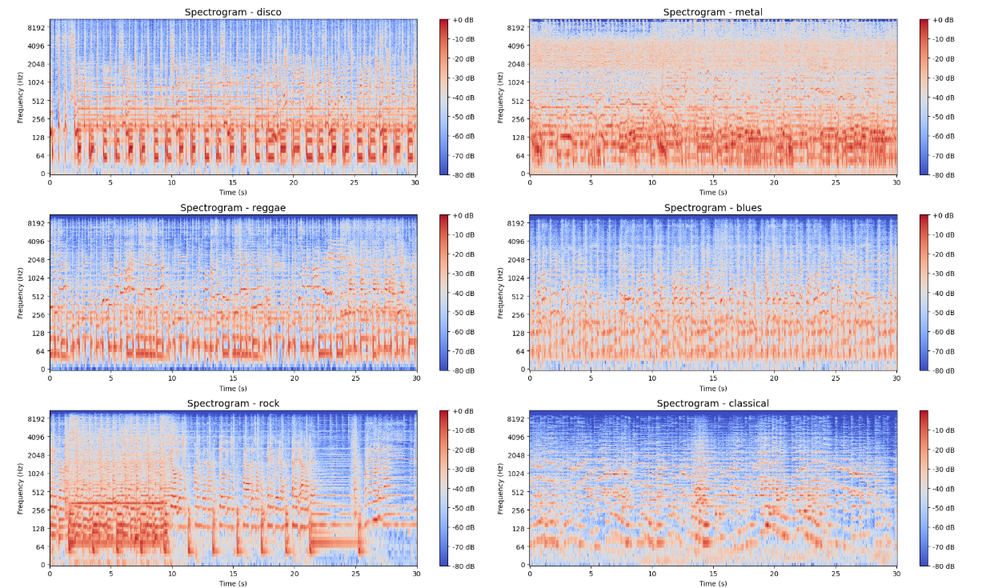

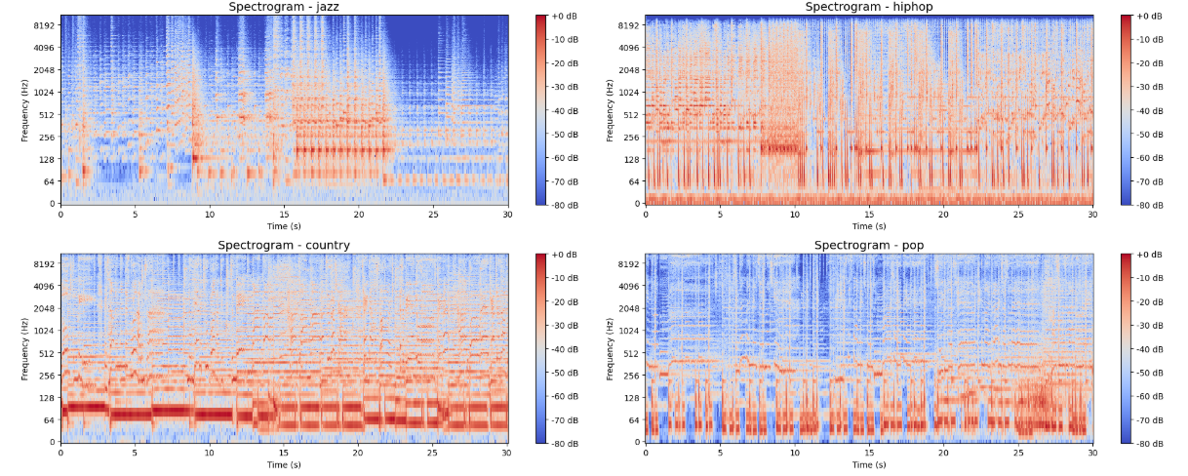

# Mel-Spectrogram

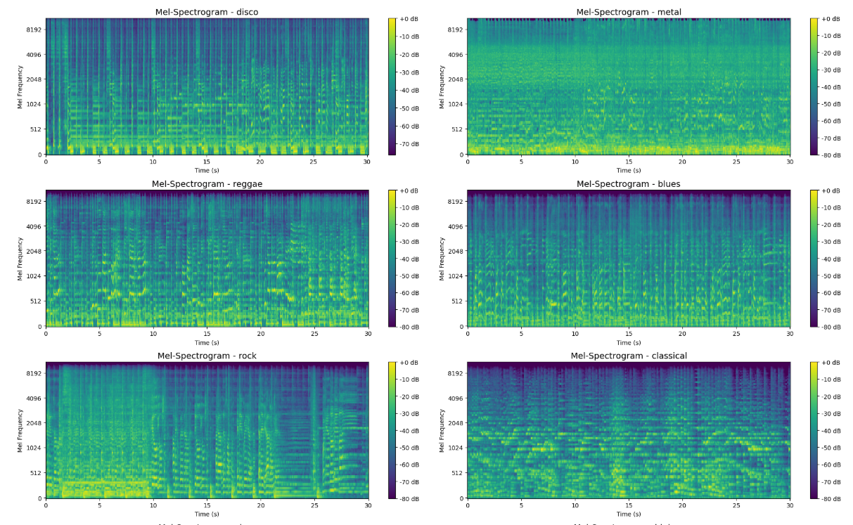

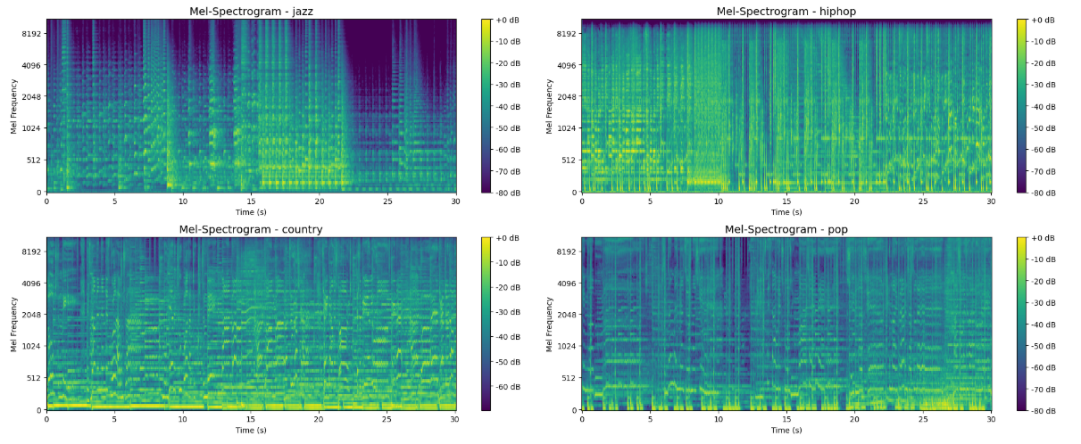

# Mel-Frequency Cepstral Coefficients (MFCCs)

MFCCs capture the timbre (tonal quality) of audio, which is one of the most distinctive characteristics of genres.

How to Use: Visualize MFCCs as a heatmap for individual songs. Compare heatmaps across genres for variations in tonal patterns.

Key Observations: Rock might show sharper MFCC patterns due to higher percussive content. Jazz or classical may show smoother, more intricate MFCC variations.

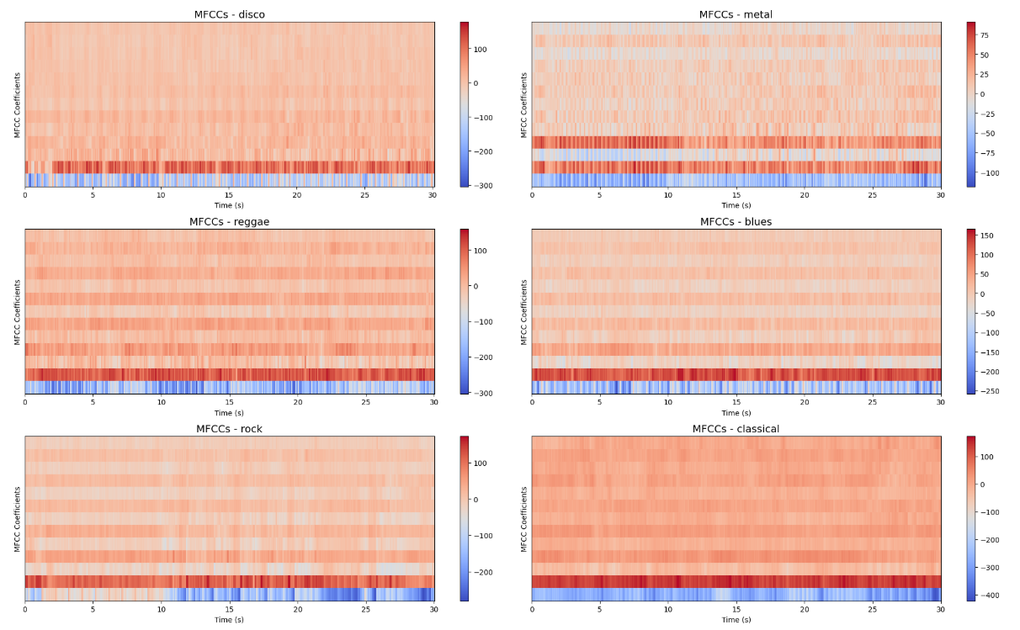

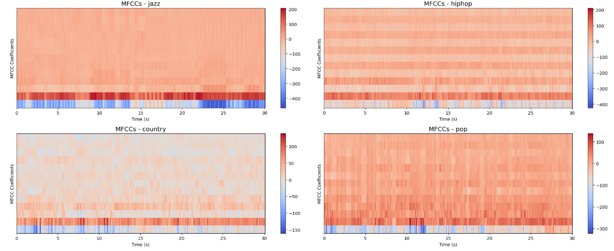

# Chroma Features

Chroma features map the audio spectrum into 12 distinct pitch classes (like keys on a piano). They are great for analyzing harmony and melody in music.

How to Use: Visualize chroma features as a heatmap to observe how pitches are distributed over time.

Key Observations: Genres like classical or jazz might show more harmonic diversity. Pop or rock might have repetitive patterns due to chord progressions.

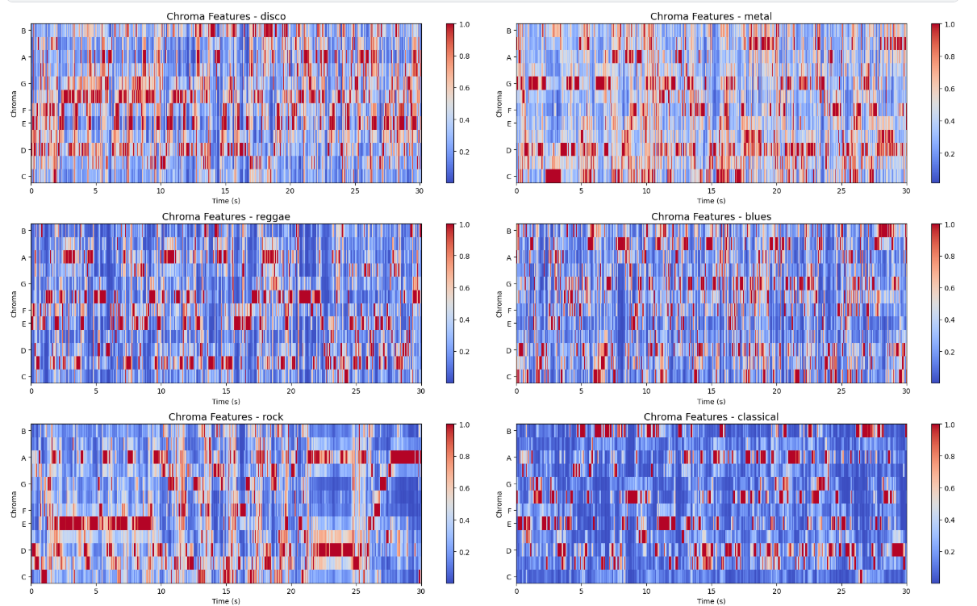

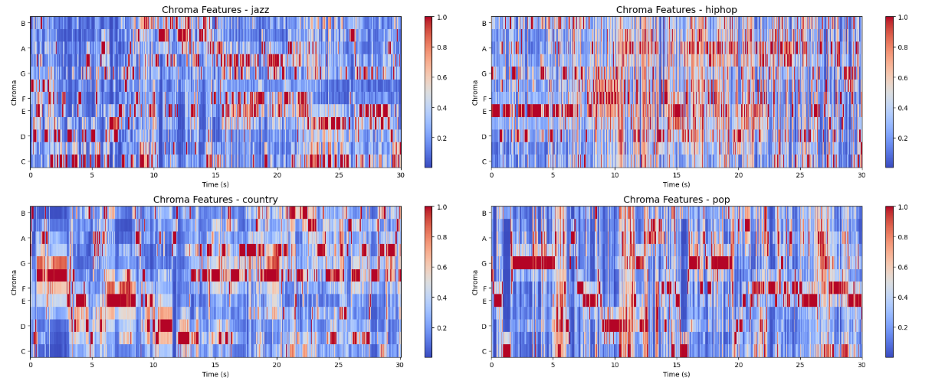

# Spectral Features

Spectral features like spectral centroid, bandwidth, and rolloff give insights into how “bright” or “dark” a genre sounds.

How to Use:

Plot these features across genres using scatter plots or boxplots.

Key Observations:

Electronic or pop may have a higher spectral centroid due to dominance of high frequencies.

Jazz or blues may have lower centroid values with more focus on lower frequencies.

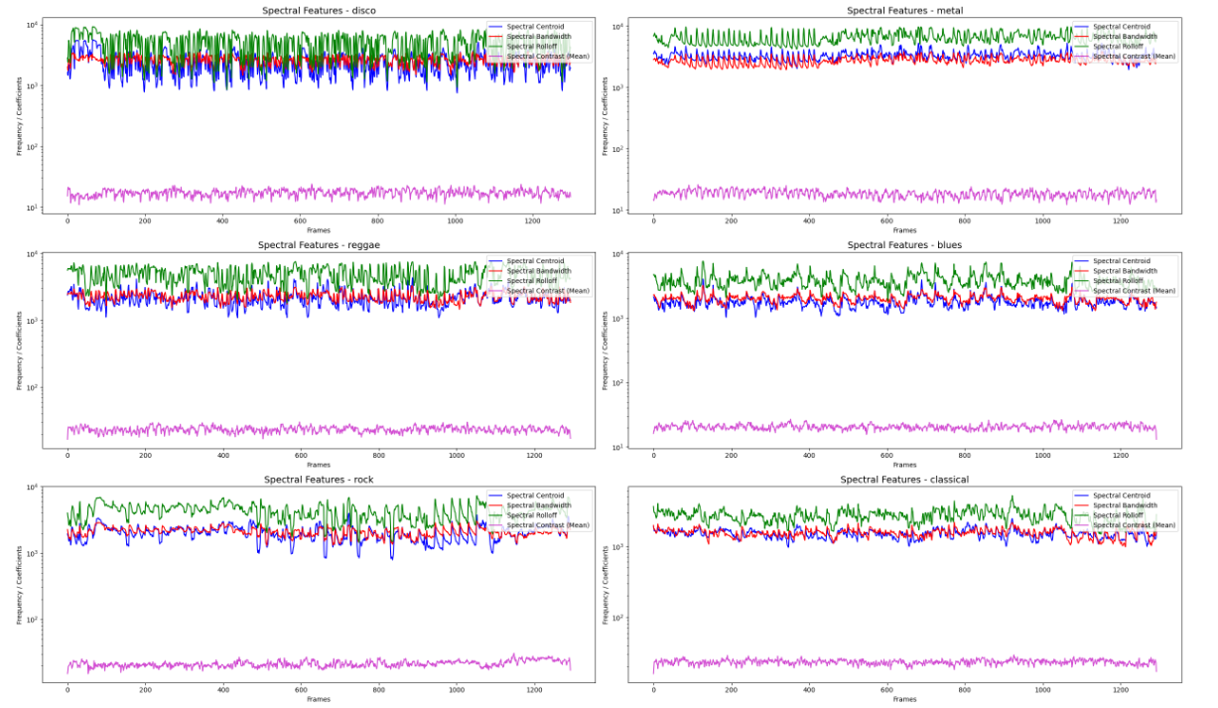

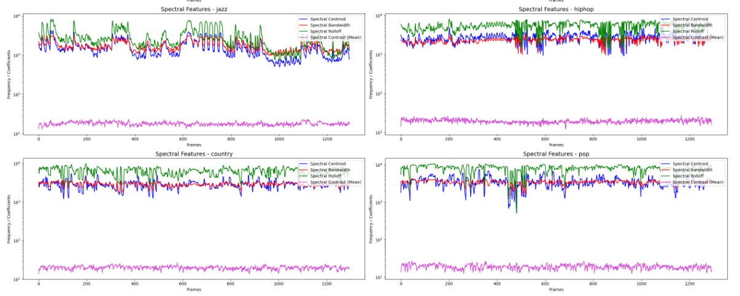

# Zero Crossing Rate (ZCR)

is an essential feature in audio analysis, representing the rate at which a signal changes its sign.

It is particularly useful for distinguishing between tonal and non-tonal signals.

# Tonal Signals:

These signals exhibit a clear and periodic frequency structure.

Examples: Notes in classical music, sine waves, vocals.

Characteristics: Lower Zero Crossing Rate (ZCR), smoother waveform.

# Non-Tonal Signals:

These are noise-like or percussive sounds with a random frequency distribution.

Examples: Drum beats, noisy instruments, metal music.

Characteristics: Higher Zero Crossing Rate (ZCR), jagged waveform

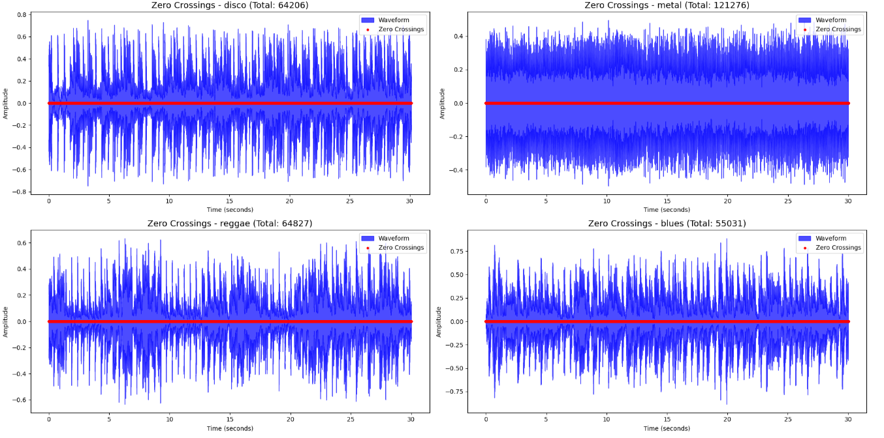

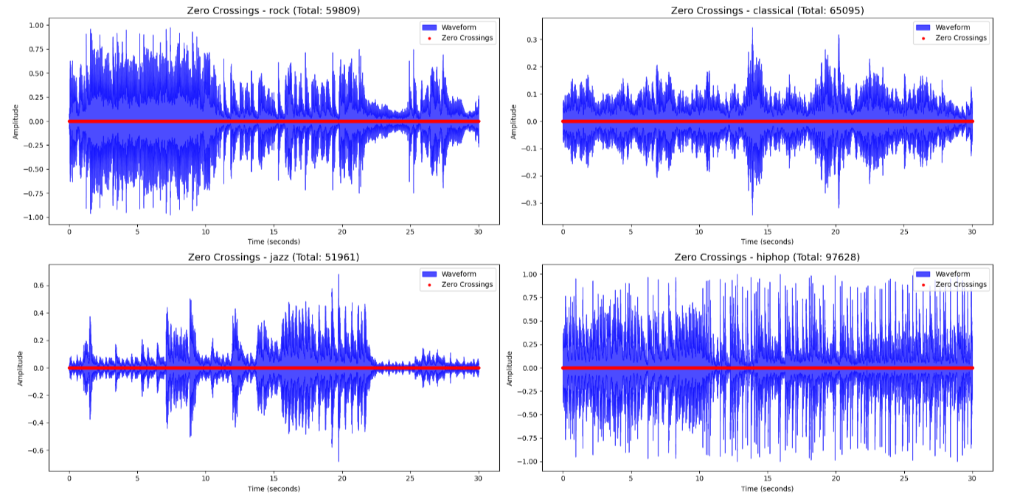

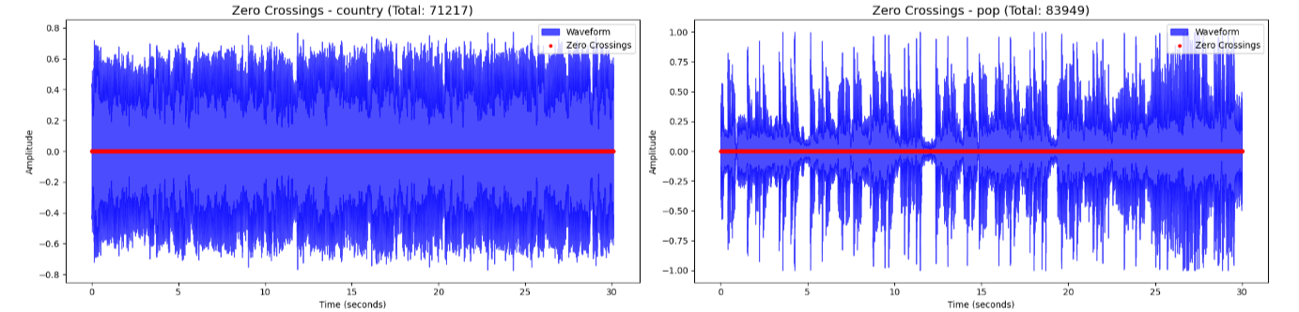

A blue waveform representing the signal.

Red dots indicating zero crossing points.

The total number of zero crossings in the plot title.

# Harmonics

#Harmonics-to-Noise Ratio (HNR)

HNR visualization can help identify the periodicity in a signal. It is particularly useful for differentiating between harmonic (tonal) and noise-like (non-tonal) signals.

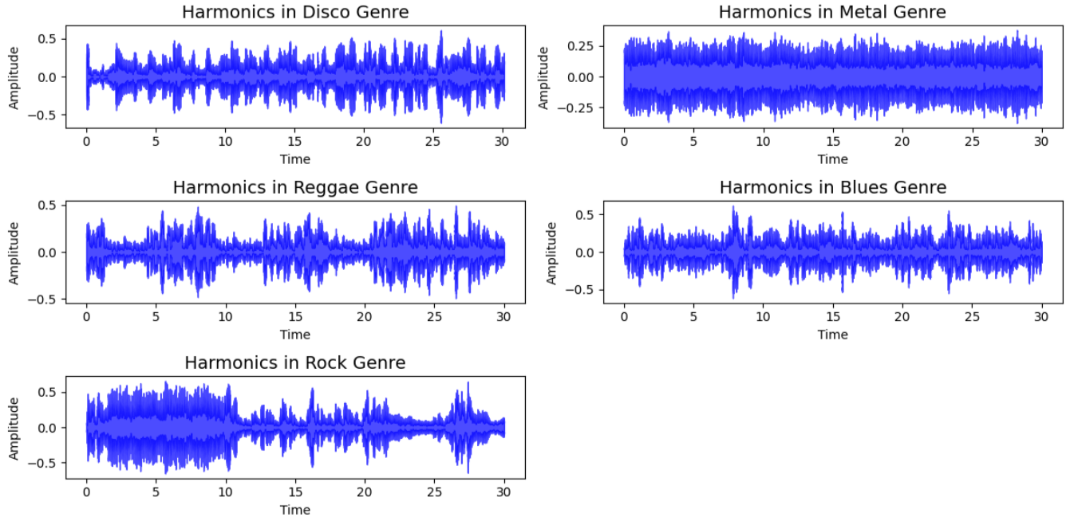

# Perceptual Features

Spectral Harmonic-to-Noise Ratio (HNR)

Librosa does not directly compute HNR, but it can be estimated indirectly by separating harmonic and percussive components and measuring their energy.

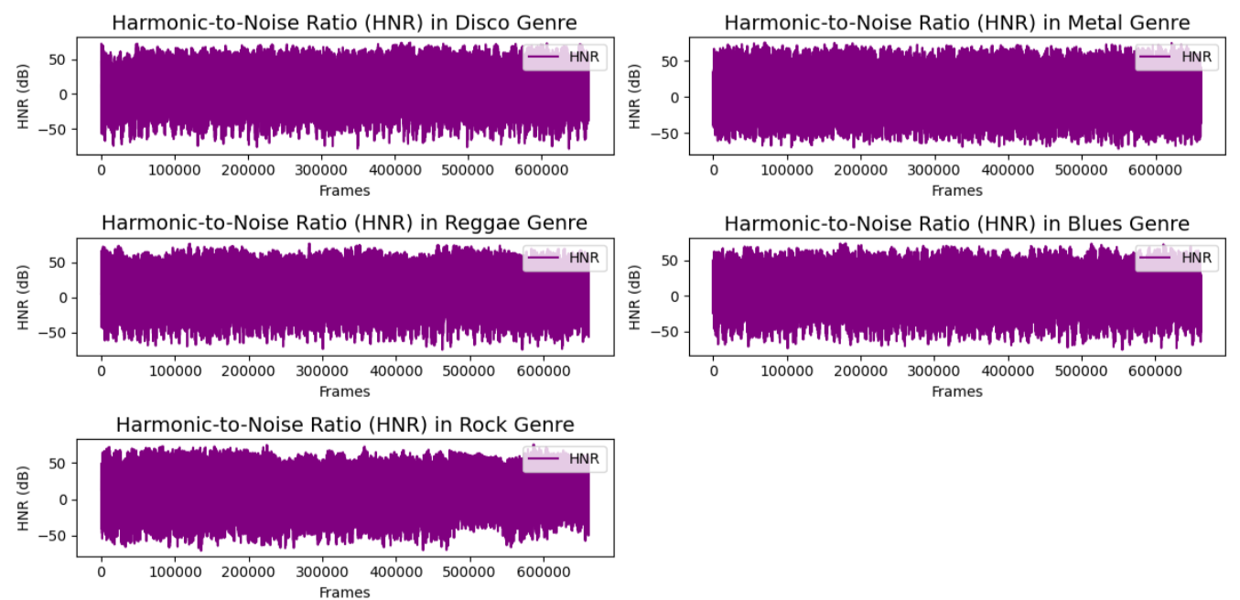

# Applications of Harmonic and Perceptual Visualizations

Music Genre Classification:

Different genres exhibit different harmonic structures (e.g., classical music has strong harmonic content, while metal may have less harmonic purity). Speech Analysis:

Harmonics are critical for analyzing vowels and distinguishing speech from noise.

Timbre Recognition:

Visualizing harmonics helps differentiate instruments (e.g., piano vs. guitar).

Audio Restoration:

HNR visualization is used to identify noise components for denoising.

# Harmonic-Percussive Source Separation (HPSS)

it is a technique to decompose an audio signal into two components:

Harmonic Component (y_harm): Contains the tonal or steady parts of the signal (e.g., sustained notes in music or a singer's voice). Percussive Component (y_perc): Contains the transient or non-tonal parts of the signal (e.g., drum hits, claps, or sharp attacks).

The harmonic component (y_harm) is plotted in purple (#A300F9). The percussive component (y_perc) is plotted in orange (#FFB100).

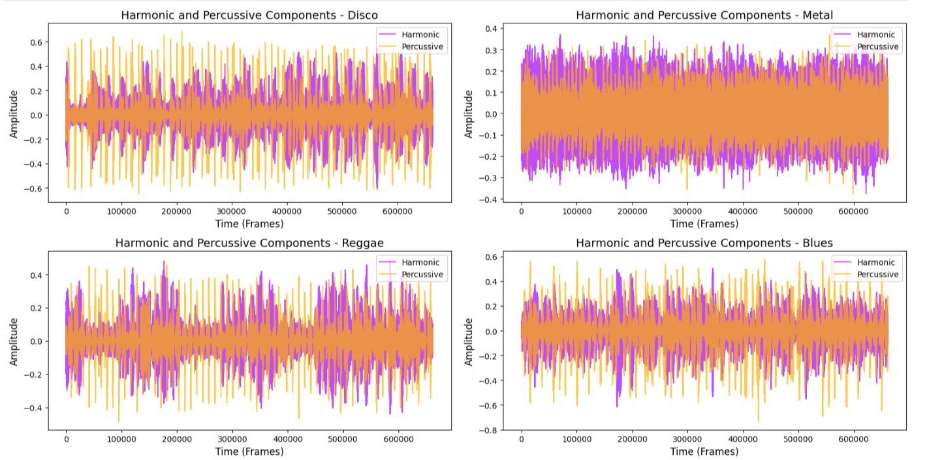

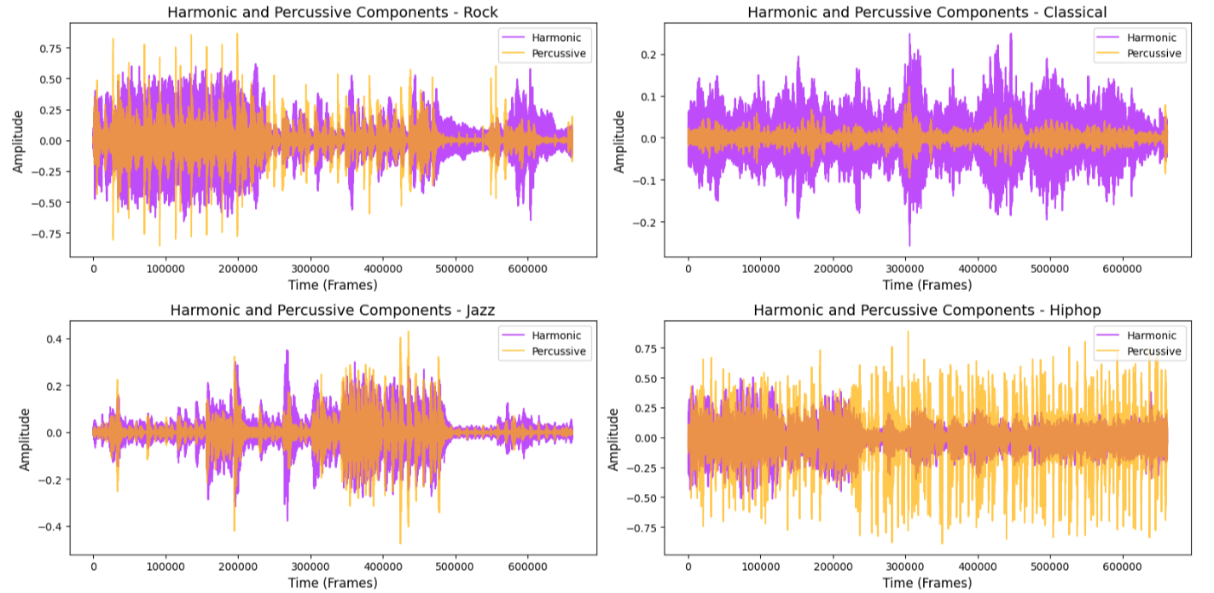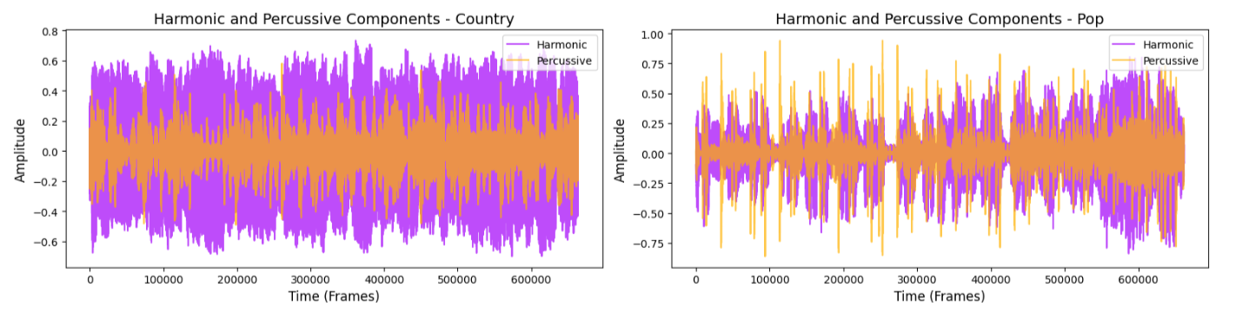

# Tempo Distribution

Tempo is a key rhythmic feature for distinguishing genres.

Faster tempos often indicate electronic or dance music, while slower tempos suggest classical or blues.

How to Use:

Extract the tempo of songs and plot the distribution across genres (e.g., a boxplot or histogram).

Key Observations:

Dance genres may cluster around higher tempos (~120–140 BPM).

Genres like blues or ballads may have lower tempos (~60–80 BPM).

Tempo (BPM) for Disco: 117.45

Tempo (BPM) for Metal: 95.70

Tempo (BPM) for Reggae: 123.05

Tempo (BPM) for Blues: 123.05

Tempo (BPM) for Rock: 123.05

Tempo (BPM) for Classical: 95.70

Tempo (BPM) for Jazz: 123.05

Tempo (BPM) for Hiphop: 117.45

Tempo (BPM) for Country: 86.13

Tempo (BPM) for Pop: 89.10

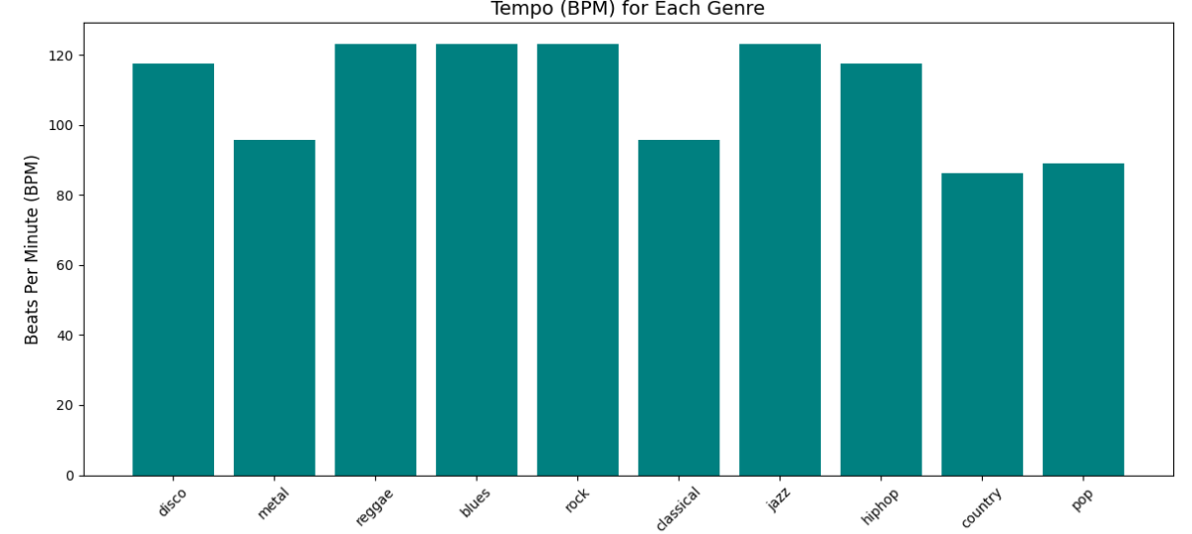

# Class Distribution

Ensure that your dataset is balanced across genres, as imbalanced classes can lead to biased models.

How to Use: Plot a bar chart showing the number of samples per genre.

Key Observations: If some genres have fewer samples, consider data augmentation or weighted loss functions during training.

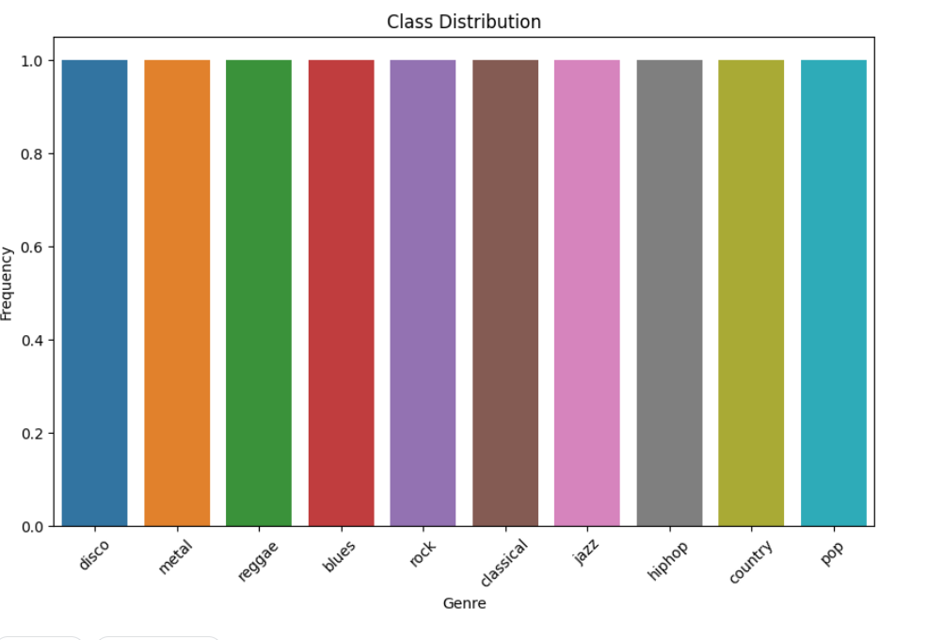

# EDA

EDA is going to be performed on the features_30_sec.csv. This file contains the mean and variance for each audio file fo the features analysed above.

So, the table has a final of 1000 rows (10 genrex x 100 audio files) and 60 features (dimensionalities).

# Correlation Heatmap for feature mean

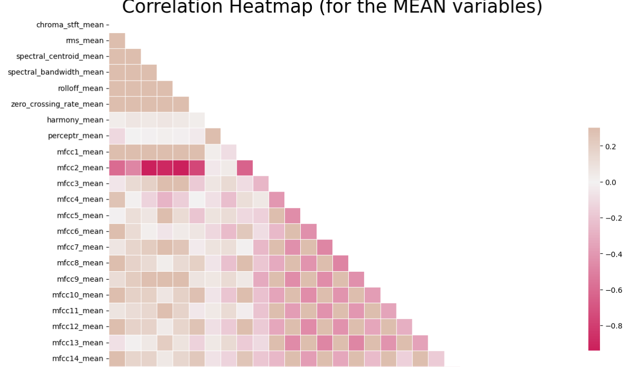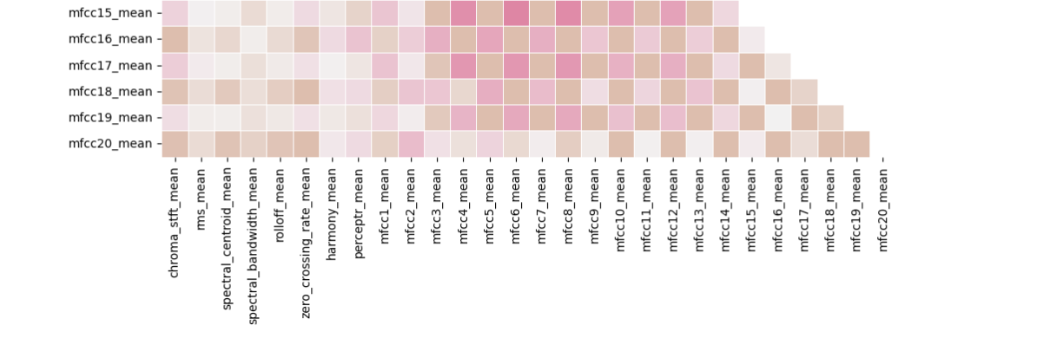Box Plot for Genres Distributions

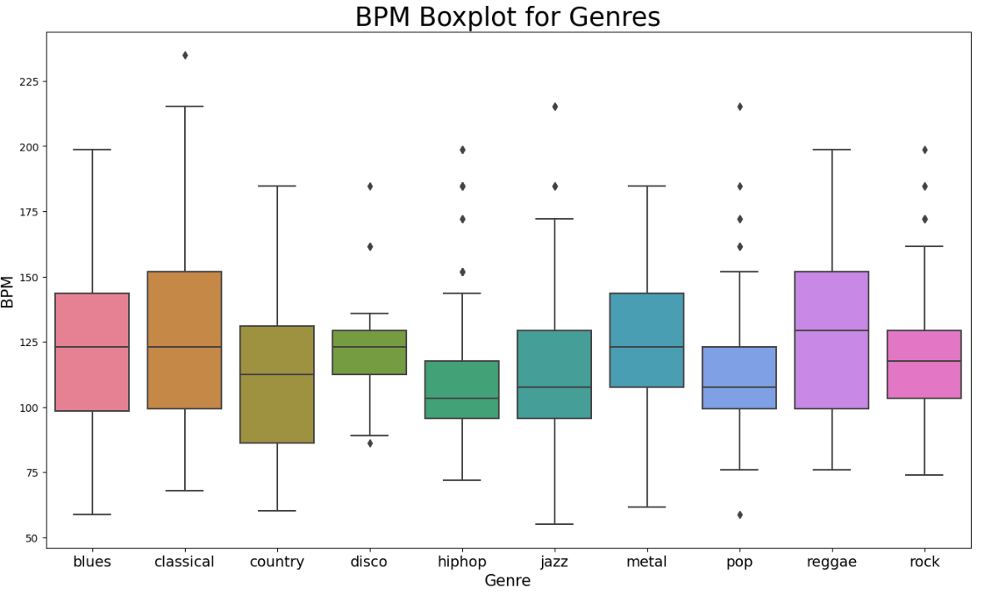

# # Principal Component Analysis -

abso visualize possible groups of genres

Normalization

PCA

#Genre Clusters (t-SNE or PCA) Use dimensionality reduction techniques like t-SNE or PCA to visualize how features group genres in lower-dimensional space.

How to Use: Extract key features (MFCCs, tempo, etc.). Apply t-SNE or PCA to reduce the feature space to 2D or 3D.

Visualize the clusters of songs based on genre

Key Observations: Overlapping clusters may indicate genre similarities (e.g., pop and rock). Distinct clusters can confirm good feature representation.

### The Scatter Plot-

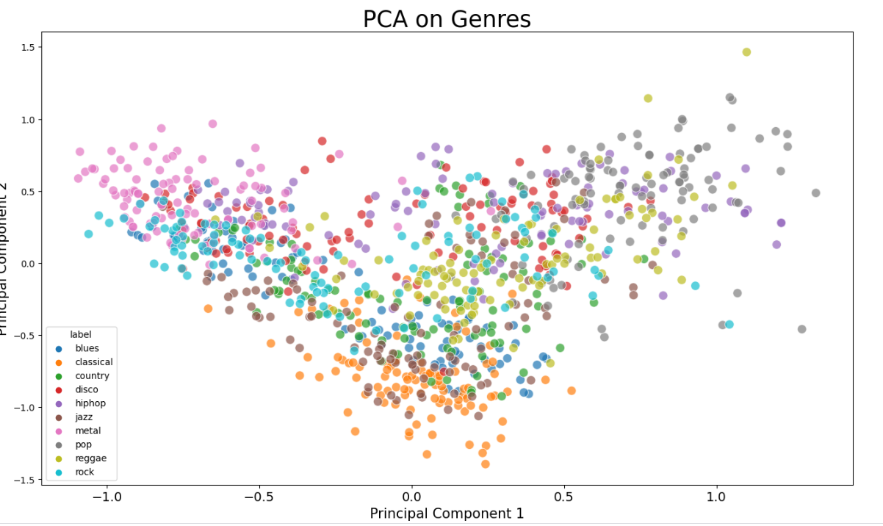Machine Learning Classification

Using the features_3_sec.csv file, we can try to build a classifier that accurately predicts for any new audio file input it's genre.

#### **Features and Target variable**

#### **creates the target and feature variables**

#### **normalizes the data**

#### **#Splitting the data into training and testing 70% - 30% split**

#### 

Accuracy Naive Bayes : 0.51952

Accuracy Stochastic Gradient Descent : 0.65532

Accuracy KNN : 0.80581

Accuracy Decission trees : 0.63997

Accuracy Random Forest : 0.81415

Accuracy Support Vector Machine : 0.75409

Accuracy Logistic Regression : 0.6977

Accuracy Neural Nets : 0.67768

Accuracy Cross Gradient Booster : 0.9009

Accuracy Cross Gradient Booster (Random Forest) : 0.74708

**Final Model**

Accuracy : 0.9009

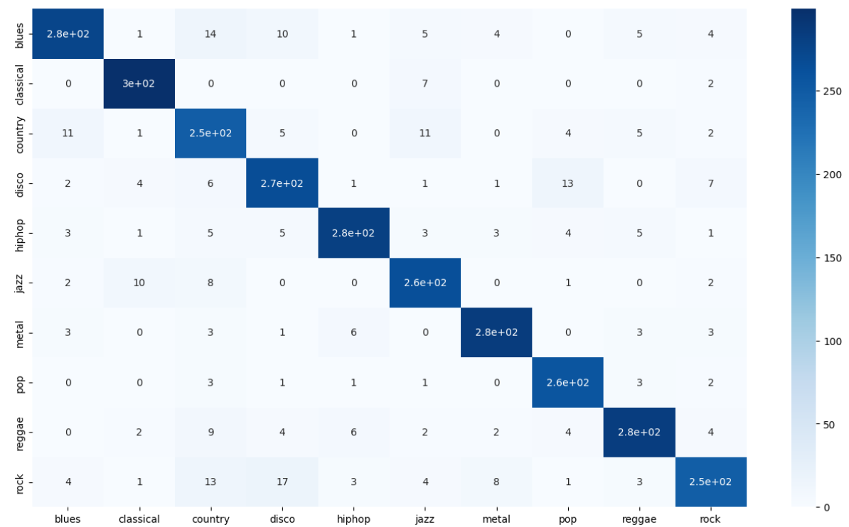

#Confusion Matrix

Visualize how well the model is classifying genres and where it’s making mistakes.

How to Use: Generate a confusion matrix after model prediction. Use a heatmap to visualize genre misclassifications.

Key Observations: Understand which genres are often confused (e.g., classical and jazz may overlap). Focus on misclassified genres to improve feature extraction or model architecture.

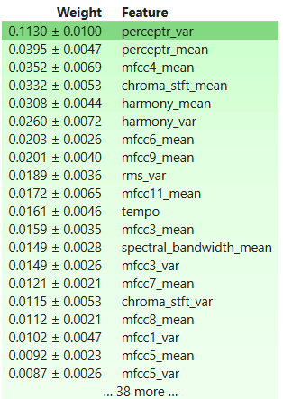

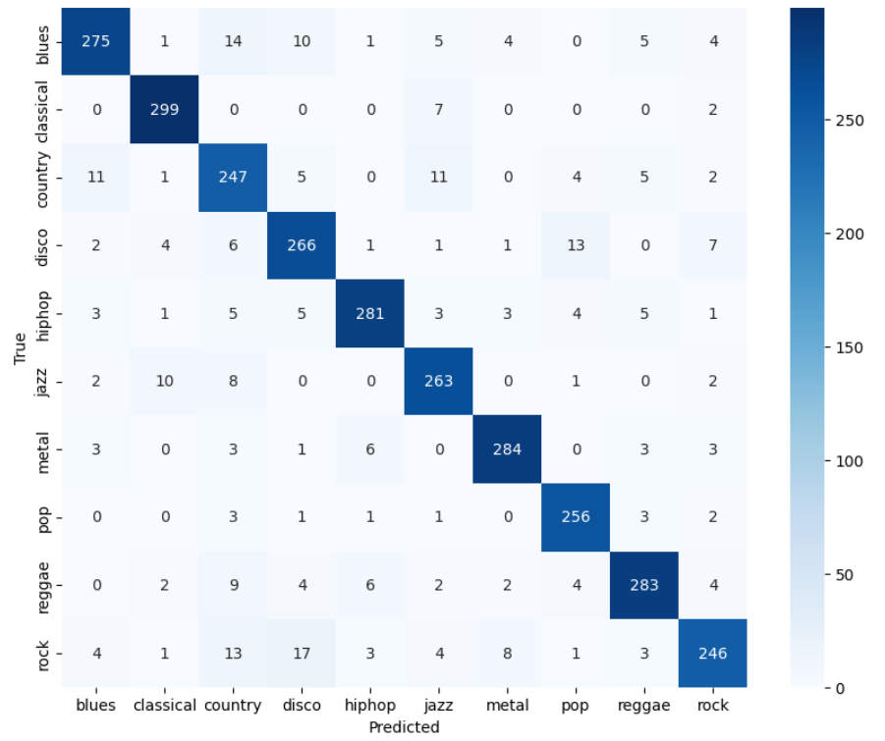

# Recommender Systems

"Recomender" Systems enable us for any given vector to find the best similarity, ranked in descending order, from the bast match to the least best match.

For Audio files, this will be done through cosine_similarity library.